FOR SALE
BY PRIVATE TREATY

OUTSTANDING INVESTMENT WITH SIGNIFICANT REDEVELOPMENT POTENTIAL
NEWPORT ROAD, CASTLEBAR
F23 RY98
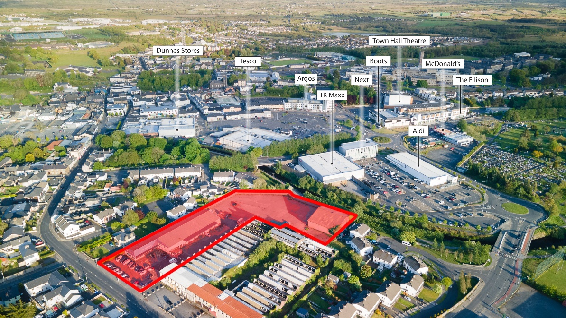
FEATURES:
- Site area of 0.9 hectares (2.2 acres)
- Existing buildings extending to circa 2,274 sq. m (24, 775 sq. ft.)
- Occupied by J.J. Griffiths Ltd. under a 21 year lease from Aug 2000 at a passing rent of €52,000 PA subject to a landlord only break option on the 15th. August 2021
- Zoned Objective B Residential/Commercial (under The Castlebar & Local Area Plan 2008-2014 as amended)
- Detailed Architect feasibility study available for substantial residential/commercial scheme

LOCATION
Prominently located on the south side of the Newport Road close to its junction with Lannagh Road in the town centre of Castlebar in west County Mayo. This is a mixed use commercial and mature residential area with a variety of occupiers which include the former Castlebar Hat Factory vacant and adjacent, a number of private residences, the Irish Wheelchair Association. To the rear of the property is the Lough Lannagh Retail Park which includes the likes of tenants as Aldi, Next & TK Maxx.
In the wider context Castlebar is the business and administrative capital of County Mayo with a growing population now in the order of 10,000. It has a broad and diversified employer base which includes Mayo University Hospital, GMIT, Mayo County Council & Baxter. Castlebar is well served with road and rail infra-structure being on the N5. N59, N84 and on the main Westport to Dublin railway line where there is a number of daily services.

DESCRIPTION
Comprises of a retail showrooms and industrial property extending to approximately 2,274 sq. m (24, 477 sq. ft.) on a substantial largely undeveloped site of 0.9 HA (2.2 acres) The site is essentially an L-shaped configuration having extensive road frontage onto the Newport Road and to the rear on the Castlebar River. The site is relatively flat and largely under concrete hard standing.
The property has been used as a motor dealership for a number of years with a mixture of retail showrooms and offices together with a substantial forecourt. To the rear there is a series of offices, storerooms and workshops. The buildings are constructed a mixture of steel portal frames with brick glazed and profile sheeting facades under a series of asbestos roofs.
FLOOR AREAS -
Showrooms & Offices 474sq.m
Warehouse 1,035 sq. m
Stores 764 sq. ms
TOTAL 2,274 sq. ms (24,467 sq. ft)
SITE- The land holding extends to 0.9 Hectares (2.2 Acres)

SERVICES
We understand the property is or can be connected to all main services available including water, sewerage, electricity and telecoms.

BER
The property has a BER Cert of B3 (800077950 – 580.14kWh/m2/yr).

ZONING
The property is located within the jurisdiction of Castlebar Urban area and Castlebar Local area Plan 2008-2014 as amended. The property is zoned Objective F Residential and Commercial. This is a unique zoning and indeed one of only two locations within the urban area of Castlebar with such a zoning. The stated objective is to protect, improve and renew the existing activities of the area and to provide primarily for residential use and such offices and retail commercial uses as or consistent with the existing mix. The plan goes on to state that there are only a few areas in this zoning category and the plan aims to protect and improve them while permitting sensitive and flexible redevelopment opportunities.
Uses within this zoning that is generally permitted or are open to consideration include housing and apartment scheme, single housing and apartment, holiday homes, guesthouse/hotel, convenience shop, medical related consultancy’s, medical centre, clinic, restaurant and pub, retail shops, schools or creche, hospital, nursing home, community hall, recreation buildings, cultural buildings such as libraries and art centres.

FEASABILITY STUDY
Our client has commissioned a detailed feasibility study recently prepared by Taylor McCartney Architects Castlebar, the feasibility outlines the potential for 2 alternative schemes.
Option 1 Development of 4 detached blocks ranging from 2 to 4 storeys comprising a total of 60 residential units together with 73 carparking spaces.
Option 2 Retail store of circa 1,800 sq. m. together with up to 38 residential units.
This detailed feasibility is available on application.

TENURE
The property is occupied by JJ Griffiths Ltd, Ford Car Dealership under a 21 year lease from 15th. August 2000 subject to a passing rent of €52,000 per annum exclusive. This is subject to a landlord only break option on the 15th. August 2021 which has been exercised on the tenant.

TERMS
The entirety of the property is being offered for sale by Private Treaty with full vacant possession, we are inviting unconditional offers for the Freehold Interest.

VIEWINGS
For further information and viewings, strictly with the Joint Selling Agents contact
Gerard O' Toole at Tuohy O' Toole at (098) 28000 or Gerard@tot.ie
Ben Pearson Agar Commercial Property (01) 2137777 or Bpearson@agar.ie

GUIDE PRICE: €750,000

DIRECTIONS
Positioned on the left hand side of the road (N59) Newport Road as you leave Castlebar.

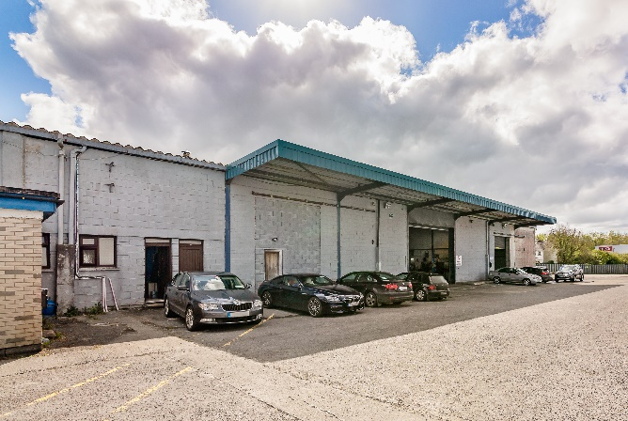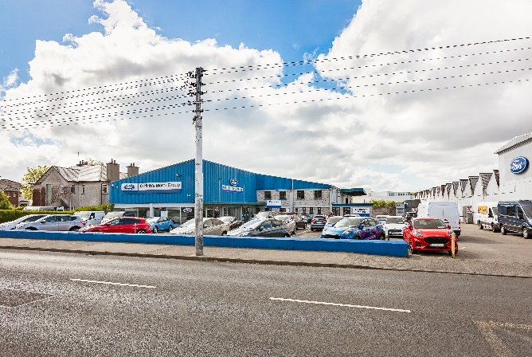
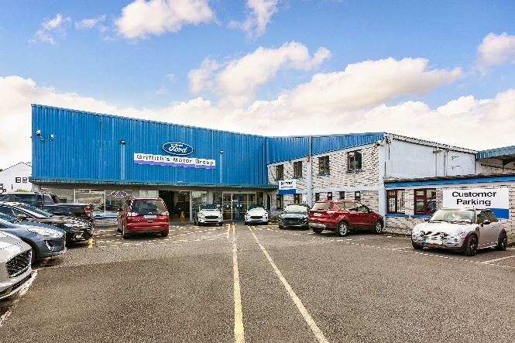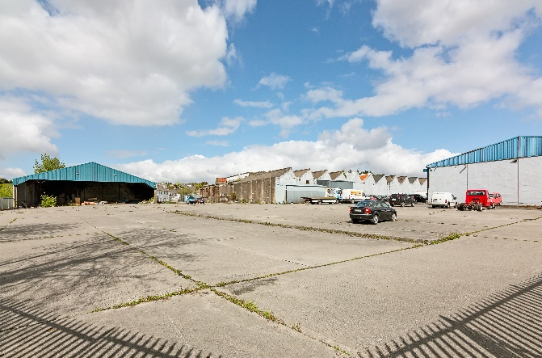
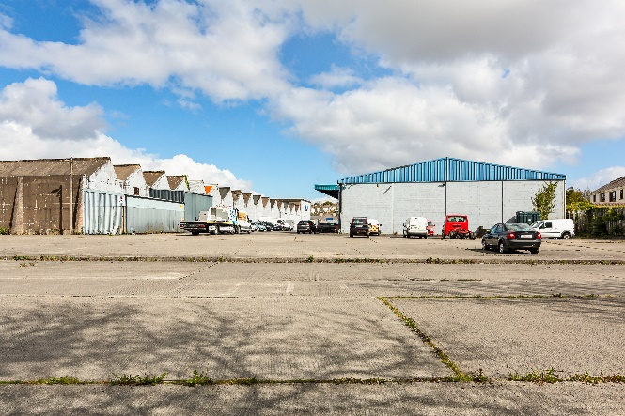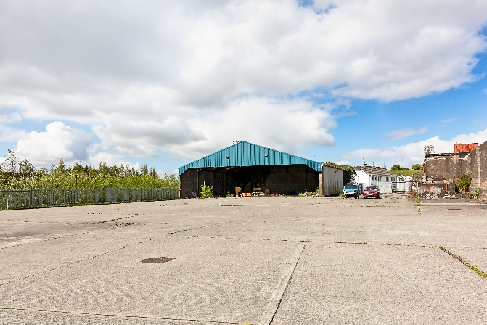
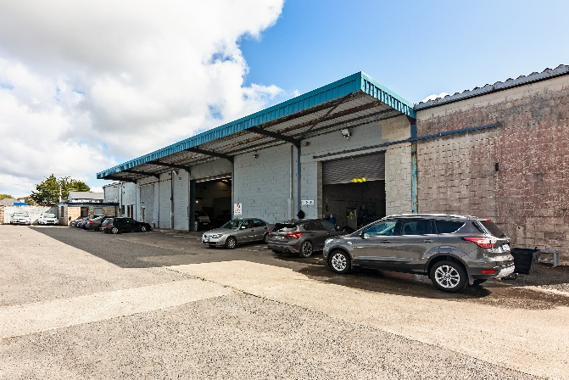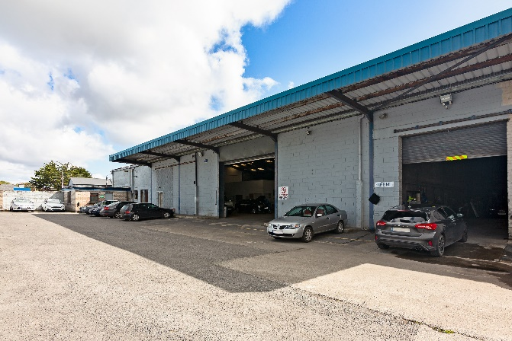

Indicative Outline of Site Boundaries
